Association Rules

Dataset:
Use the Online retail dataset to apply the association rules.
Data Preprocessing:
Pre-process the dataset to ensure it is suitable for Association rules, this may include handling missing values, removing duplicates, and converting the data to appropriate format.
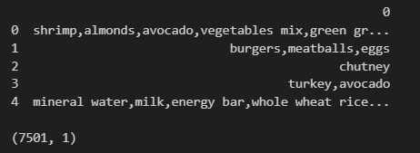

Association Rule Mining:
Apriori requires data in a format where each column represents an item, and each row represents a transaction. Set thresholds for support, confidence, and lift to extract meaningful rules.
- Support: Set min_support (e.g., 0.02) to filter out infrequent itemsets.
- Confidence: Set min_threshold in association_rules() to control rule strength.
- Lift: A lift > 1 indicates a strong positive association
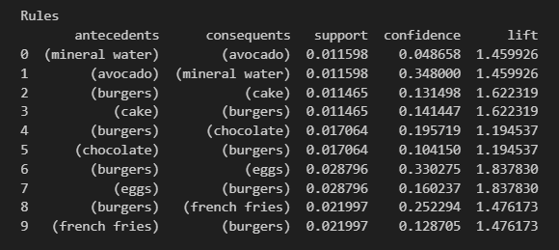
- Support: The frequency of a rule in the dataset.
- Confidence: The probability that customers who buy the antecedent also buy the consequent.
- Lift: How much more likely customers are to buy the consequent when they buy the antecedent (Lift > 1 indicates a strong association).

Business Insights & Recommendations
